Activity: Natural Join Two Tables

Consider the tables **Employee** and **Drives**:

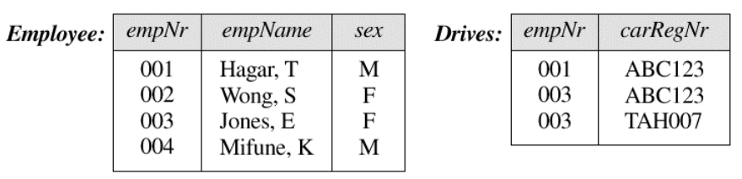

Show the resulting table after performing a natural join:

Employee ⋈ Drives